WEB PROGRAMMING(PHP)
PRACTICAL/CASE STUDY FILE
(CES 2)
2023-2026
SUBMITTED BY:
(TANISH GUPTA)
(0231BCA061)
SECTION-BCA 6 (M)
SUBMITTED TO:
(Mr. NRIPESH KUMAR NRIP )

Bharati Vidyapeeth University (Deemed to be University)
Institute of Management & Research, New Delhi
A-4, Paschim Vihar, New Rohtak Road, New Delhi-110063

INDEX

SNO | CASE STUDY | PAGE NO
1 | Order Processing System
2 | Reusable PHP Utility Library
3 | Form Submission and File Logging System
4 | Demonstrating Cookies & Sessions for Order Processing System:
5 | Student Record Management System

CASE I:
Order Processing System :
- Develop an HTML form to collect customer and product information.
- Implement logic to calculate total amount (price × quantity).
- Create an admin page to view all stored orders.
- Apply basic validation and security measures (e.g., required fields).
- Test the complete workflow from order placement to data storage.

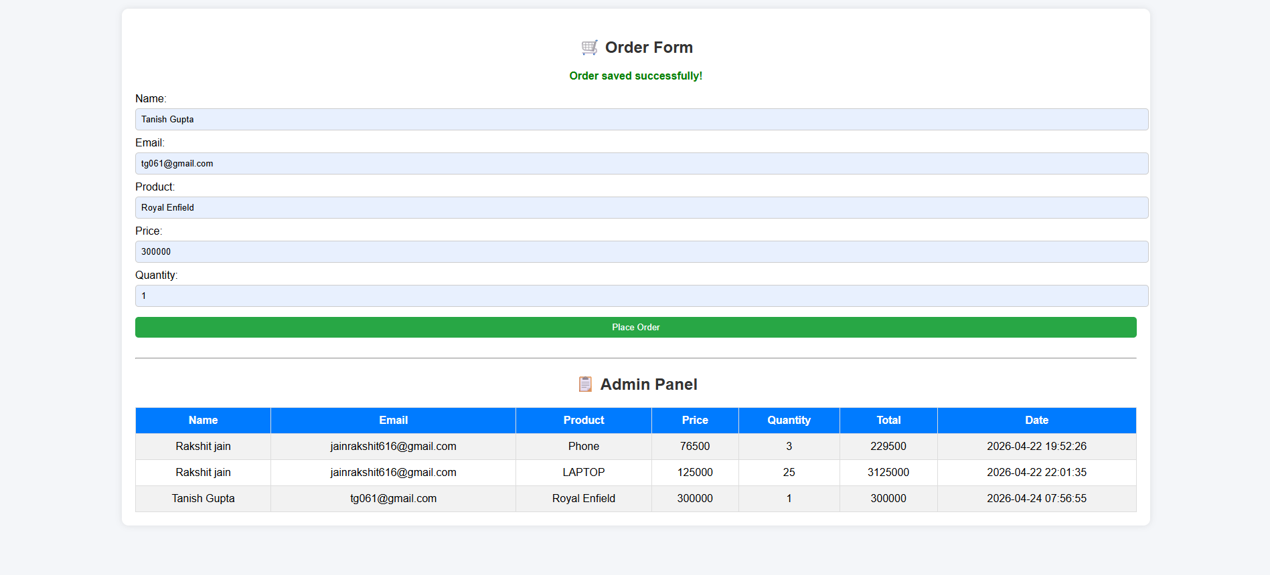

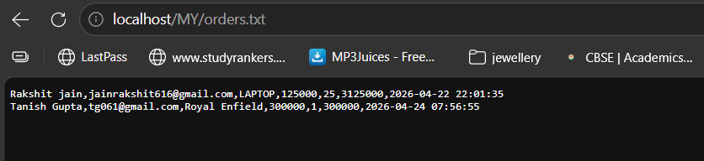

CASE1:
Order Processing System

Answer:

<?php
$file = "orders.txt";
$message = "";

// Handle form submission
if ($_SERVER["REQUEST_METHOD"] == "POST") {
$name = htmlspecialchars($_POST['name']);
$email = htmlspecialchars($_POST['email']);
$product = htmlspecialchars($_POST['product']);
$price = $_POST['price'];
$quantity = $_POST['quantity'];
// Calculate total
$total = $price * $quantity;
// Save data
$data = $name . "," . $email . "," . $product . "," . $price . "," . $quantity . "," . $total . "," . date("Y-m-d H:i:s") . "\n";

if (file_put_contents($file, $data, FILE_APPEND)) {
$message = "Order saved successfully!";
} else {
$message = "Error saving order!";
}
}
?>

<!DOCTYPE html>
<html>
<head>
<title>Order Processing System</title>
<style>
body {
font-family: Arial;
background: #f4f6f9;
margin: 0;
padding: 20px;
}

h2 {
text-align: center;
color: #333;
}

.container {
width: 80%;
margin: auto;
background: #fff;
padding: 20px;
border-radius: 10px;
box-shadow: 0 0 10px rgba(0,0,0,0.1);
}
form {
margin-bottom: 20px;
}
input {
width: 100%;
padding: 8px;
margin: 5px 0 10px;
border: 1px solid #ccc;
border-radius: 5px;
}
input[type="submit"] {
background: #28a745;
color: white;
border: none;
cursor: pointer;
}
input[type="submit"]:hover {
background: #218838;
}
table {
width: 100%;
border-collapse: collapse;
}
table, th, td {
border: 1px solid #ddd;
}

th {
background: #007bff;
color: white;
}
th, td {
padding: 10px;
text-align: center;
}
tr:nth-child(even) {
background: #f2f2f2;
}
.message {
text-align: center;
color: green;
font-weight: bold;
}
</style>
</head>
<body>
<div class="container">
<h2>🛒 Order Form</h2>
<p class="message"><?php echo $message; ?></p>
<form method="POST">
Name:
<input type="text" name="name" required>
Email:
<input type="email" name="email" required>
Product:
<input type="text" name="product" required>
Price:
<input type="number" name="price" required>
Quantity:
<input type="number" name="quantity" required>
<input type="submit" value="Place Order">
</form>
<hr>
<h2>📋 Admin Panel</h2>
<table>
<tr>
<th>Name</th>
<th>Email</th>
<th>Product</th>
<th>Price</th>
<th>Quantity</th>
<th>Total</th>
<th>Date</th>
</tr>

<?php
if (file_exists($file)) {
$orders = file($file);

foreach ($orders as $order) {
$data = explode(",", trim($order));
echo "<tr>
<td>{$data[0]}</td>
<td>{$data[1]}</td>
<td>{$data[2]}</td>
<td>{$data[3]}</td>
<td>{$data[4]}</td>
<td>{$data[5]}</td>
<td>{$data[6]}</td>
</tr>";
}
} else {
echo "<tr><td colspan='7'>No orders found</td></tr>";
}
?>
</table>
</div>
</body>
</html>

CASE II:
Reusable PHP Utility Library :
- Develop reusable PHP functions.
- Implement arrays for configuration and data handling.
- Design utility classes using OOP concepts.
- Create a modular structure for easy integration into other projects.
- Improve clean coding and structured programming practices.

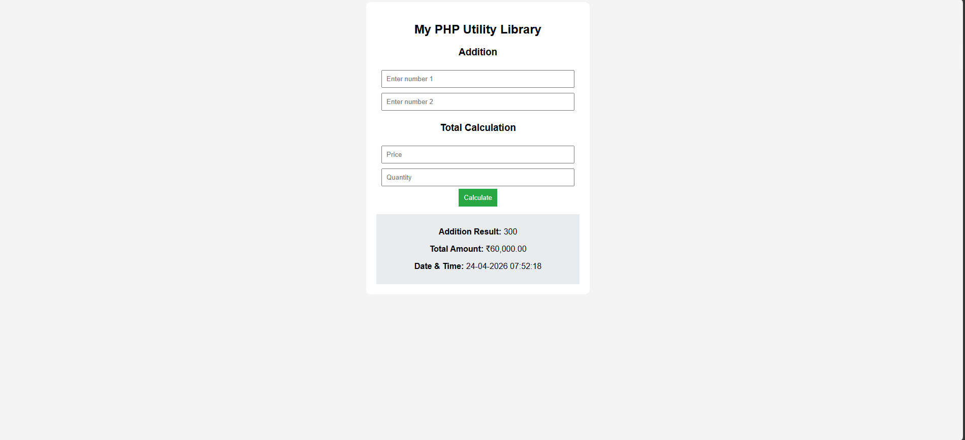

CASE III:
Form Submission and File Logging System:
- Develop a user input form using HTML.
- Process form data using PHP.
- Validate and sanitize user inputs.
- Store submitted data into a structured log file (.txt or .log).
- Implement file handling operations (open, write, append, close).
- Display confirmation message after successful submission.

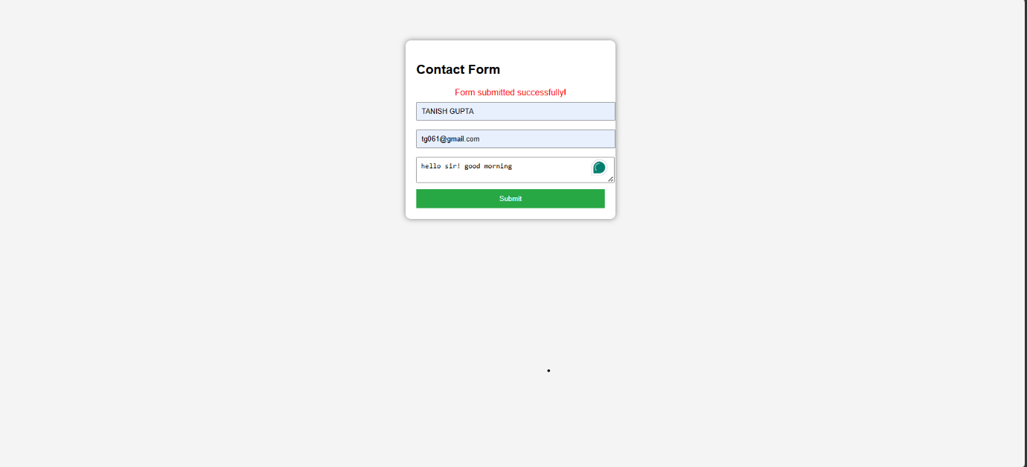

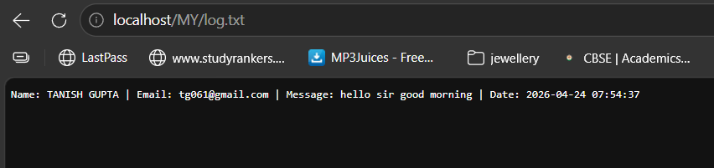

CASE IV:
Demonstrating Cookies & Sessions for Order Processing System:
- Design order form.
- Implement session-based cart storage.
- Set and retrieve cookies for user preference.
- Display dynamic order summary.
- Clear session after order confirmation.
- Test cookie persistence across browser refresh.

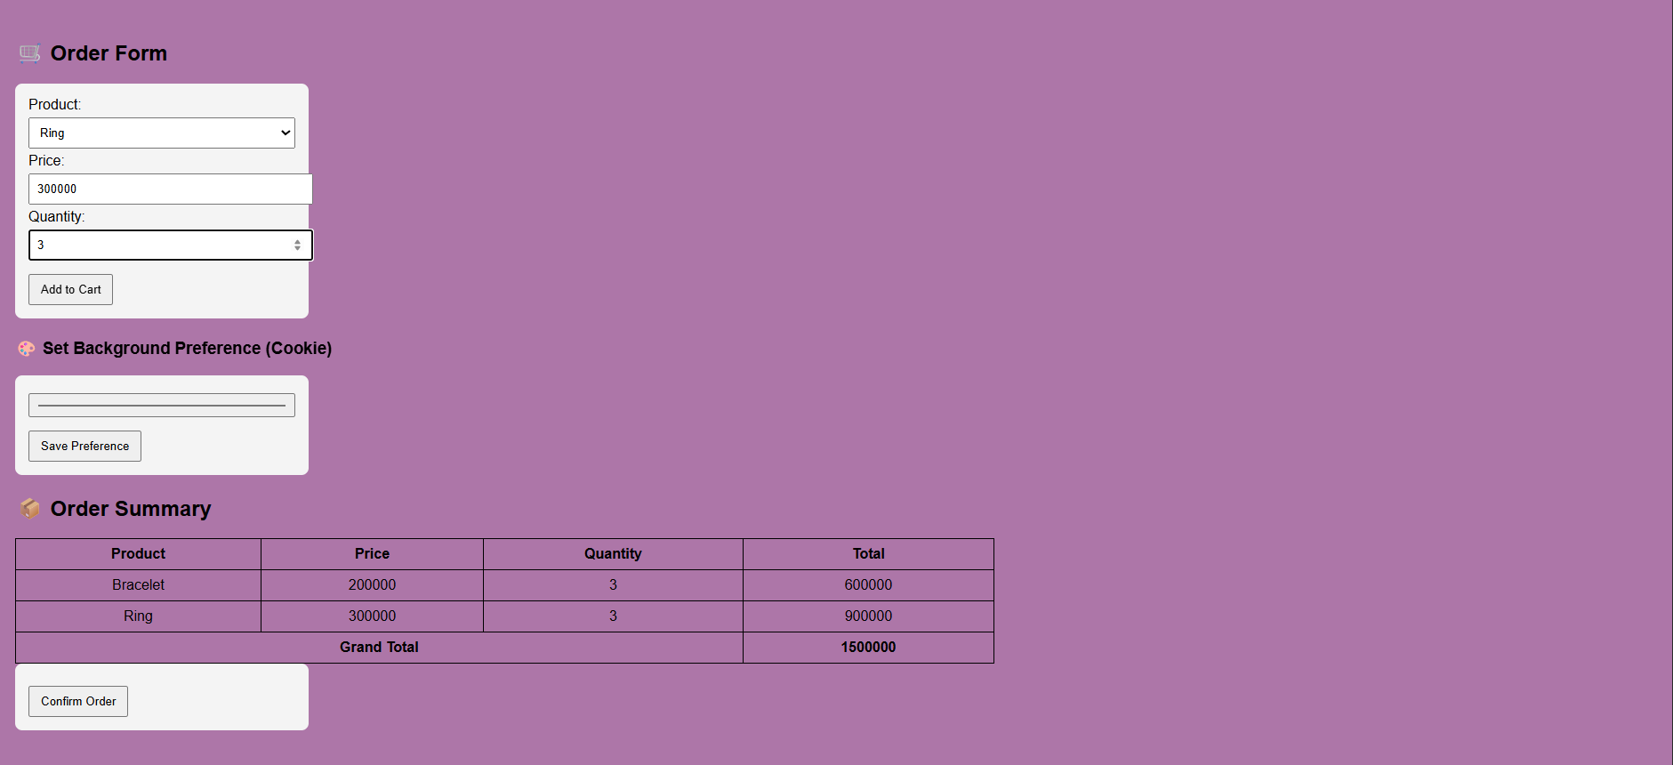

CASE 4:
Demonstrating Cookies & Sessions for Order Processing System:

Answer:

<?php
session_start();
// Initialize cart
if (!isset($_SESSION['cart'])) {
$_SESSION['cart'] = [];
}
// Handle form submission
if (isset($_POST['add_to_cart'])) {
$product = htmlspecialchars($_POST['product']);
$price = (int)$_POST['price'];
$qty = (int)$_POST['quantity'];

$total = $price * $qty;

$_SESSION['cart'][] = [
"product" => $product,
"price" => $price,
"quantity" => $qty,
"total" => $total
];
}
// Set cookie (user preference)
if (isset($_POST['set_preference'])) {
$color = $_POST['bgcolor'];
setcookie("bgcolor", $color, time() + 3600); // 1 hour
}
// Clear session after order
if (isset($_POST['confirm_order'])) {
session_destroy();
header("Location: " . $_SERVER['PHP_SELF']);
exit();
}
// Get cookie
$bgcolor = isset($_COOKIE['bgcolor']) ? $_COOKIE['bgcolor'] : "#ffffff";
?>
<!DOCTYPE html>
<html>
<head>
<title>Order Processing System</title>
<style>
body {
font-family: Arial;
background-color: <?php echo $bgcolor; ?>;
padding: 20px;
}
form {
background: #f4f4f4;
padding: 15px;
margin-bottom: 20px;
border-radius: 8px;
width: 300px;
}
input, select {
width: 100%;
padding: 8px;
margin: 5px 0;
}
table {
border-collapse: collapse;
width: 60%;
}
th, td {
border: 1px solid black;
padding: 8px;
text-align: center;
}
button {
padding: 8px 12px;
margin-top: 10px;
}
</style>
</head>
<body>
<h2>🛒 Order Form</h2>
<form method="post">
<label>Product:</label>
<select name="product" required>
<option value="Ring">Ring</option>
<option value="Necklace">Necklace</option>
<option value="Bracelet">Bracelet</option>
</select>
<label>Price:</label>
<input type="number" name="price" required>
<label>Quantity:</label>
<input type="number" name="quantity" required>
<button type="submit" name="add_to_cart">Add to Cart</button>
</form>
<h3>Set Background Preference (Cookie)</h3>
<form method="post">
<input type="color" name="bgcolor" required>
<button type="submit" name="set_preference">Save Preference</button>
</form>
<h2>Order Summary</h2>
<?php if (!empty($_SESSION['cart'])): ?>
<table>
<tr>
<th>Product</th>
<th>Price</th>
<th>Quantity</th>
<th>Total</th>
</tr>
<?php
$grandTotal = 0;
foreach ($_SESSION['cart'] as $item):
$grandTotal += $item['total'];
?>
<tr>
<td><?php echo $item['product']; ?></td>
<td><?php echo $item['price']; ?></td>
<td><?php echo $item['quantity']; ?></td>
<td><?php echo $item['total']; ?></td>
</tr>
<?php endforeach; ?>
<tr>
<th colspan="3">Grand Total</th>
<th><?php echo $grandTotal; ?></th>
</tr>
</table>
<form method="post">
<button type="submit" name="confirm_order">Confirm Order</button>
</form>
<?php else: ?>
<p>No items in cart.</p>
<?php endif; ?>
</body>
</html>

CASE V:
Student Record Management System:
- Design database and student table.
- Implement add, view, edit, delete functionality.
- Create dynamic interface using PHP loops.
- Validate user input.
- Test system for multiple entries.

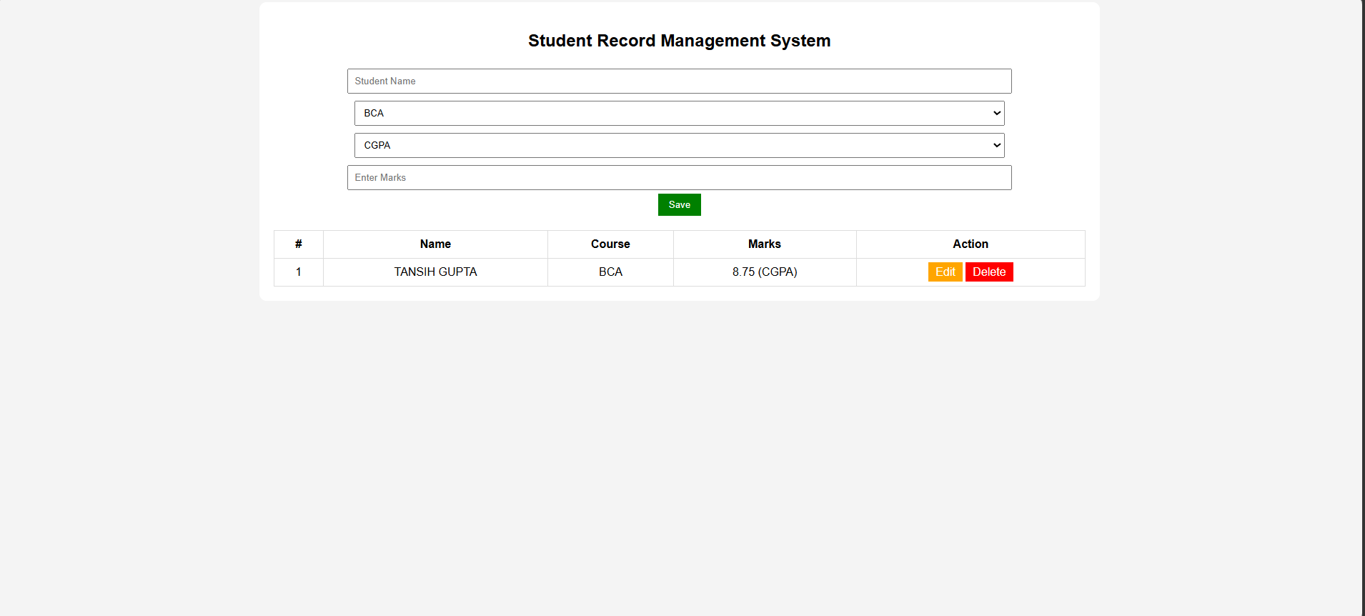

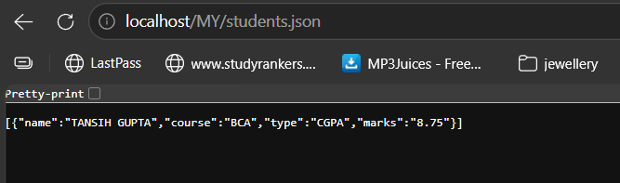

CASE 5:
Student Record Management System:

Answer:

<?php
$file = "students.json";
$data = file_exists($file) ? json_decode(file_get_contents($file), true) : [];
// ADD / UPDATE
if (isset($_POST['save'])) {
$id = $_POST['id'];
$name = trim($_POST['name']);
$course = $_POST['course'];
$type = $_POST['type'];
$marks = trim($_POST['marks']);
$valid = false;
// Validation based on type
if ($type == "CGPA" && $marks >= 0 && $marks <= 10) $valid = true;
if ($type == "Percentage" && $marks >= 0 && $marks <= 100) $valid = true;
if ($type == "Total" && $marks >= 0 && $marks <= 500) $valid = true;
if ($name != "" && $valid) {
$record = [
"name" => $name,
"course" => $course,
"type" => $type,
"marks" => $marks
];
if ($id == "") {
$data[] = $record;
} else {
$data[$id] = $record;
}
file_put_contents($file, json_encode($data));
}
header("Location: ".$_SERVER['PHP_SELF']);
}
// DELETE
if (isset($_GET['delete'])) {
unset($data[$_GET['delete']]);
$data = array_values($data);
file_put_contents($file, json_encode($data));
header("Location: ".$_SERVER['PHP_SELF']);
}
// EDIT
$editData = ["name"=>"", "course"=>"", "type"=>"CGPA", "marks"=>""];
$editId = "";
if (isset($_GET['edit'])) {
$editId = $_GET['edit'];
$editData = $data[$editId];
}
?>
<!DOCTYPE html>
<html>
<head>
<title>Student Record System</title>
<style>
body { font-family: Arial; background:#f4f4f4; text-align:center; }
.box { background:white; padding:20px; width:60%; margin:auto; border-radius:10px; }
input, select { padding:8px; margin:5px; width:80%; }
button { padding:8px 15px; background:green; color:white; border:none; }
table { width:100%; margin-top:20px; border-collapse:collapse; }
th, td { padding:10px; border:1px solid #ddd; }
a { text-decoration:none; padding:5px 10px; }
.edit { background:orange; color:white; }
.delete { background:red; color:white; }
</style>
<script>
function validateMarks() {
let type = document.getElementById("type").value;
let marks = document.getElementById("marks").value;
if (type == "CGPA" && (marks < 0 || marks > 10)) {
alert("CGPA must be between 0 and 10");
return false;
}
if (type == "Percentage" && (marks < 0 || marks > 100)) {
alert("Percentage must be between 0 and 100");
return false;
}
if (type == "Total" && (marks < 0 || marks > 500)) {
alert("Total marks must be between 0 and 500");
return false;
}
return true;
}
</script>
</head>
<body>
<div class="box">
<h2>Student Record Management System</h2>
<form method="post" onsubmit="return validateMarks()">
<input type="hidden" name="id" value="<?php echo $editId; ?>">
<input type="text" name="name" placeholder="Student Name"
value="<?php echo $editData['name']; ?>" required><br>
<!-- COURSE DROPDOWN -->
<select name="course" required>
<?php
$courses = ["BCA","BBA","MBA","BBALLB","MCA","LLB"];
foreach ($courses as $c) {
$selected = ($editData['course'] == $c) ? "selected" : "";
echo "<option $selected>$c</option>";
}
?>
</select><br>
<!-- MARK TYPE -->
<select name="type" id="type">
<option <?php if($editData['type']=="CGPA") echo "selected"; ?>>CGPA</option>
<option <?php if($editData['type']=="Percentage") echo "selected"; ?>>Percentage</option>
<option <?php if($editData['type']=="Total") echo "selected"; ?>>Total</option>
</select><br>
<input type="number" step="0.01" id="marks" name="marks"
placeholder="Enter Marks"
value="<?php echo $editData['marks']; ?>" required><br>
<button type="submit" name="save">Save</button>
</form>
<table>
<tr>
<th>#</th>
<th>Name</th>
<th>Course</th>
<th>Marks</th>
<th>Action</th>
</tr>
<?php foreach ($data as $index => $row): ?>
<tr>
<td><?php echo $index + 1; ?></td>
<td><?php echo $row['name']; ?></td>
<td><?php echo $row['course']; ?></td>
<td>
<?php
echo $row['marks'] . " (" . $row['type'] . ")";
?>
</td>
<td>
<a class="edit" href="?edit=<?php echo $index; ?>">Edit</a>
<a class="delete" href="?delete=<?php echo $index; ?>" onclick="return confirm('Delete?')">Delete</a>
</td>
</tr>
<?php endforeach; ?>
</table>
</div>
</body>
</html>

